ORCHIDS OF NORTH WEST HUNGARY
Neusiedler-see-Hansag NP – Balaton Upland NP


During this one-week-long tour our main goal will be not just to show the most interesting orchid species of NW Hungary, but to learn about the special habitats, local ecosystem as well. Depending on the group’s interest we would be happy to share our knowledge about the birds, butterflies and other interesting members of the local fauna as well.

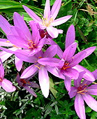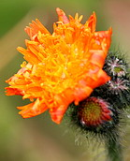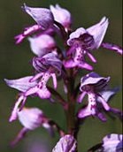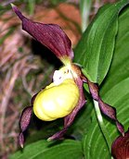

Day1
First we visit wet meadows close to Sopron which are influenced by the vicinity of the Alps and lowland areas. One of the first orchids to find during the tour should be Listera ovate and Dactylorhiza majalis. But we will find many more interesting wildflowers as well such as Cirsium rivulare, Lathyrus pannonicus, Clematis integrifolia, Cirsium pannonicum, Sesleria uliginosa. Iris sibirica will decorate the area in large numbers.
Close to Sopronkőhida we will look for Liparis loeselii, Pedicularis palustris, Pinguicula vulgaris, Dactylorhiza ochroleuca and Epipactis palustris.

Day2
We visit a recently discovered bog-meadow which is incredibly rich in rarities and various habitats in a small area. 4 Dactylorhiza species and a couple of more orchid species can be found on the patches of wet meadows. Other interesting species include Veratrum album, Iris sibirica and different Carex-rarities.
Later on we stop at a unique location where we can find acidic soil and limestone-based soil and their characteristic flora side by side with Pulsatilla species, Muscari tenuiflorum, Himantoglossum adriaticum, just to mention a few.

Day3
Our last visits in the Sopron region will be at some sunny slopes with different meadows than during the first days. These habitats characterized by patches of Quercus pubescens and dry meadows with several orchid species, some really sought after ones. Some of the possibilities: Epipactis atrorubens, Ophrys insectifera, Orchis militaris, Orchis puprurea, Orchis ustulata, and if we are lucky we can find even Cypripedium calceolus as well.
Beside the orchids any other species create a fantastic carpet of wildflowers here, such as different Linum species, Polygala major, Iris graminea and some Allium species.

Day4
Today we start with visiting an interesting oak-hornbeam forest where large carpets of Gladiolus imbricatus covers the forest floor. Beside that we should find a wide range of species including Dianthus superbus, Galium pumilum, Hypericum dubium, Salix aurita, Platanthera bifolia, some Carex and Dryopteris species. The nearest village is locally famous for its Roman-style church which dates back to the early Middle Ages. As we travel further in a hidden valley at an isolated little meadow we can admire Hemerocallis lilio-asphodelus, Carex buekii and Alchemilla xanthochlora. Finally we go to an oxbow lake of the River Raba where the water will be covered with Trapa natans, but there will be some more rarities as well, like Scirpus radicans and Carex repens.

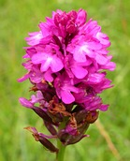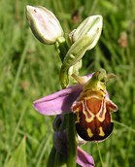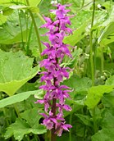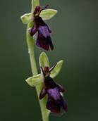

Day5
Today we visit the so called Keszthely Hills which characterized by steep southern dolomite slopes. It has a strong Mediterranean effect, perfect place to observe interesting species, normally with much more southern distribution. On the driest slopes live Paronychia cephalotes, Aethionema saxatile and Jovibarba hirta. At the steppe-meadows and in the small, short paches of woods among dolomite domes we can find Orchis tridentata, Ophrys insectifera, Dictamnus albus and Iris graminea.
At another part of the Keszthely Hill we start our walk from the bottom of a valley filled with beechwood with Cyclamen purpurascens, Lilium martagon and within a couple of hundred meters we will be at a completely different world at rocky outcrops surrounded by Amelanchier ovalis, Daphne cneorum and different Stipa species.

Day6
We spend another day at the Balaton Upland National Park, visiting some more wet meadows around Sümeg, which is decorated by an attractive mediaeval fortress and Tapolca, which famous for a cave system which visitors can visit by rowing boats. It is quite incredible that even alongside the main road the meadows are full with wildflower and other botanical raritites: more than 20 Carex species, Iris sibirica and Asphodelus albus.

Day7
Depending on your flight schedule (leaving afternoon or evening from Vienna) on the way back to the airport we can either stop to take photos of huge number of Asphodelus albus close to Sárvár and botanize a bit or we walk up to the top of a volcanic hill, where beside the panoramic view we can enjoy masses of flowering Aethionema saxatile.
Fact File
- 7 days in NW Hungary; start and finish in Vienna, Austria; using 2 accommodation
Highlights
- topography, geology and soils as a background of compilation of vegetation
- complete overview of plant associations from the mountain zone to the plains
- rare and typical plant species of the region with focus on the Pannonian specialities
Accommodation
3 nights at Sopron and 3nights at Balaton Upland National Park, Hungary

